Instructions for SlackUP process:

Note (Because of Slack the only people able to perform an Export of the teams data are the admins)

**Instruction on how to export**: <https://get.slack.help/hc/en-us/articles/201658943-Export-your-team-s-Slack-history>

1. Start your Slack Export which will give you a folder of json files
2. Download Xampp with php (unless you already have a php compiler installed)

**Download for Xampp:**  <https://www.apachefriends.org/download.html>

1. Put the php script “slack2html.php” inside your export folder.

Should look like this:

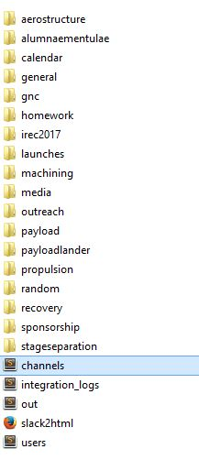

1. Next step has 2 options:
2. Add “C:\xampp\php” to your environment PATH

Then in the export folder type “php slack2html.php”

1. Go in the export folder and type C:\xampp\php slack2html.php
2. The php script should generate all your html files in a folder named slack2html in the directory that your export folder is contained. (1 UP)
3. Once you have your html files, upload them to the SlackUP drive in a folder named after the date of your backup.